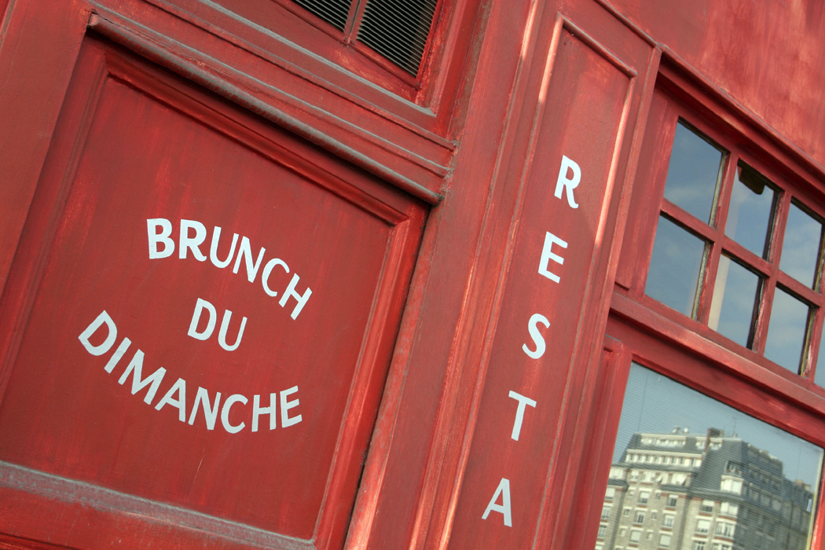
Here is an example of the type of final project you can submit. You may choose to do a newsletter to recount a story or an event in this format. It is easy to do. There is a link on the moodle page for intructions on how to set up a newsletter format in Microsoft Word. You can just follow along and then type in your story and add images to make it more interesting.

Here is an example of how to wrap text around a graphic. It really adds a lot of pizzazz to your story.

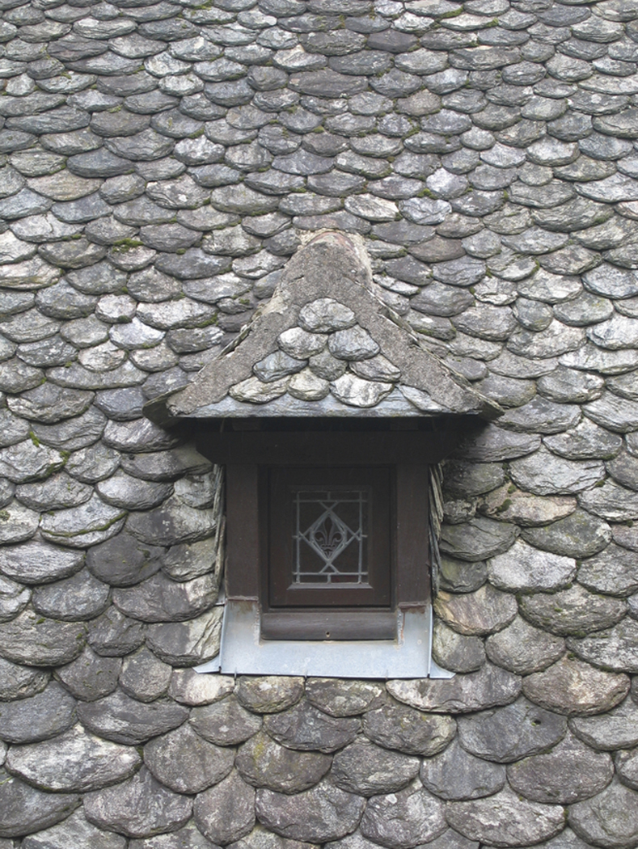
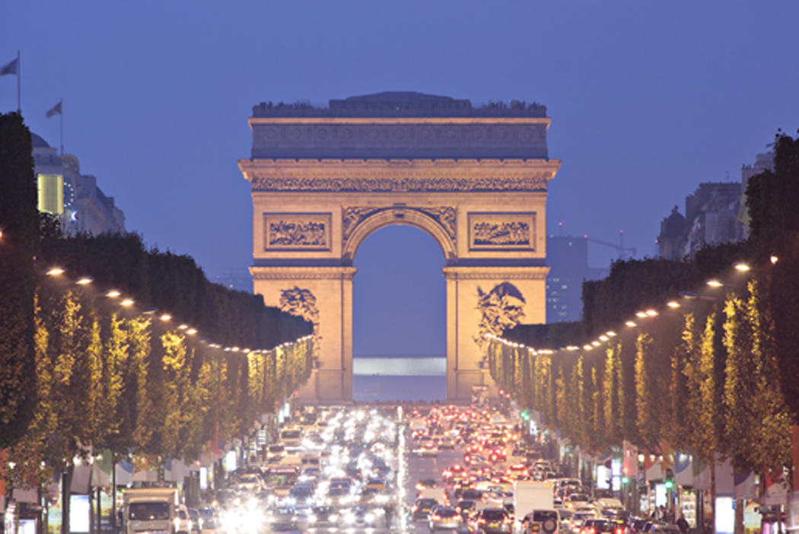
When you are working on this you will see a lot of text boundary lines. Don’t worry they will go away with your finished product.

You can play with where you want your images. You can even have the image as your background. Choose wisely if this is the option you want. Some images make the text very difficult to read.

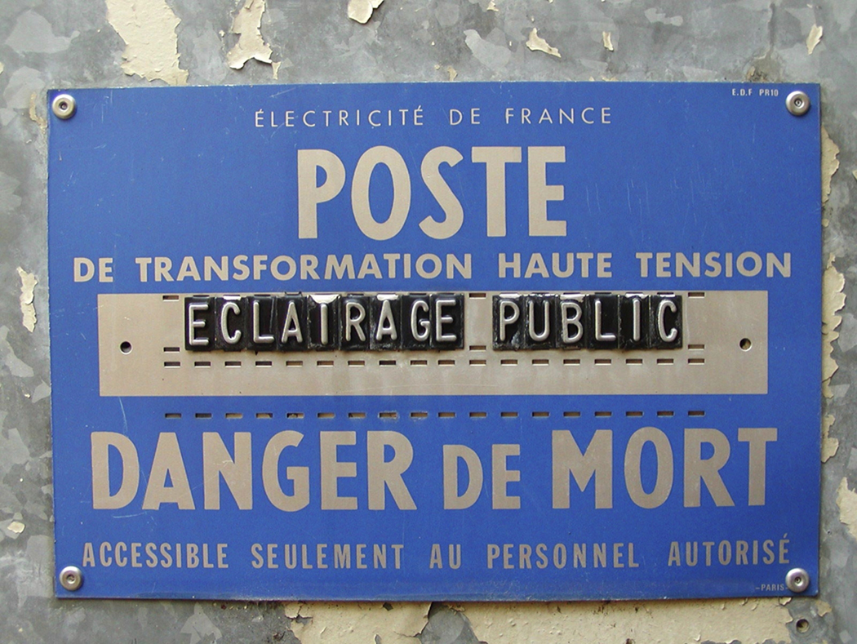
Keep in mind that you want the images to help the reader understand your story. Don’t choose an image that you think is cool, but doesn’t have anything to do with your story.
It can be distracting and the reader may not be able to understand you story well.


The images you choose can be centered, to the left or to the right. It really is quite simple and fun to do. It creates a more professional and polished product.

You can also add “hairlines” to set off the articles. This feature helps to delineate between different articles or in our case between different chapters or to help the reader to identify the beginning,
middle,

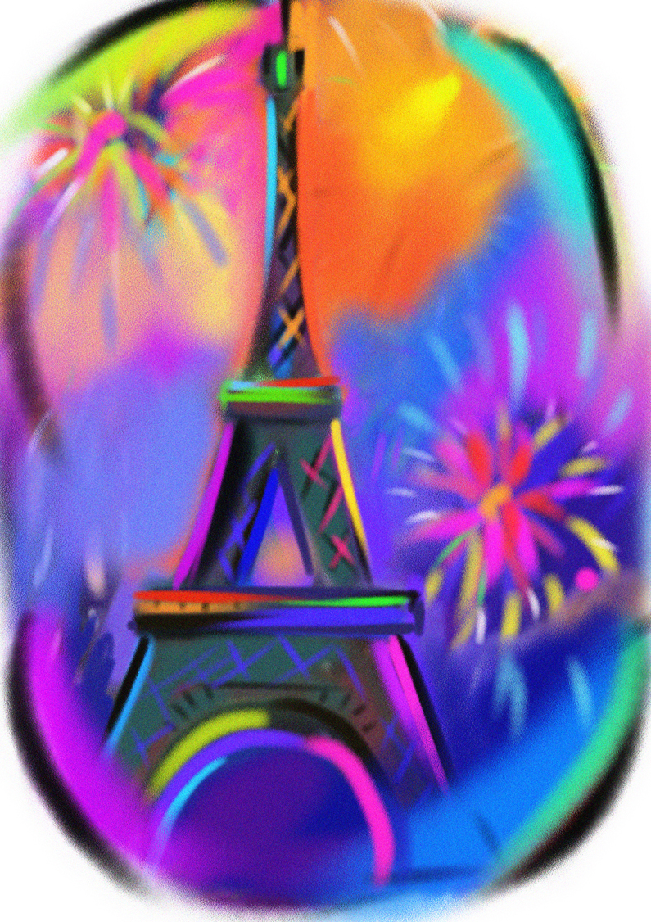
and the end. How cool is that!!!
Nous adorons le
francais!

The large heading at the top of the page is called a Masthead. You can make this as fun, engaging and artistic as you like.

The

